Introduction to Data Science

Supermarket Sales

Group 8

Group Members
- Chetan Bandi
- Soundarya Bachu
- Swati Sonaji Kolpekwar
- Vishaka Sharma

Introduction

Objective
This dataset of sales observations aims to predict customer satisfaction levels for two groups: members and normal visitors. Satisfaction is categorized into two levels: low (0) and high (1). Key influencing factors include Quantity, Total, Gross Income, and Unit Price. The goal is to use Rating as the predicted variable, as customer satisfaction helps identify potential revenue generators.

Data Source
The dataset of 1000 supermarket, Supermarket_sales.xlsx, was sourced from Kaggle to analyze customer satisfaction trends. Categorizing the rating variable provides clear insights into overall satisfaction, aiding in sustainable growth analysis and developing effective marketing strategies.

Sno | Variable | Description
1 | Customer_Type | Member, Normal
2 | Gender | Male, Female
3 | Product_line | Product_line,Health and beauty,Electronic accessories,Home and lifestyle,Sports and travel,Food and beverages,Fashion accessories
4 | Unit_Price | Price of a single unit purchased
5 | Quantity | Number of items purchased
6 | Tax | Tax charged on the purchase, calculated as (Unit Price * Quantity) * 5%
7 | Total | Total revenue for a transaction, calculated as (Unit Price * Quantity) + Tax
8 | Date | Date of purchase
9 | Time | Time of purchase
10 | Payment | Mode of Payment
11 | Cogs | Cost of goods purchased
12 | Gross_income | Total revenue minus COGS (Total - Cogs)
13 | Rating | 0 (Unsatisfied), 1 (Satisfied)

Data Partition
Customers with satisfaction scores between 0-7 are categorized as low-level, while scores above 7 are high-level. The data is split 80-20 for training and testing, ensuring a balanced dataset without the need for over-sampling or under-sampling.

Graphs and Summary Statistics

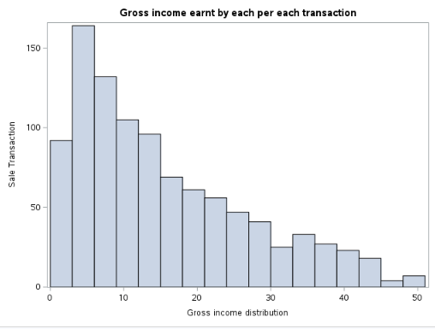

The histogram shows the distribution of sales transactions by gross income. It is right-skewed, indicating that high-gross-income transactions are rare. Most transactions fall within the lowest category, generating a gross income between 0 and 10.

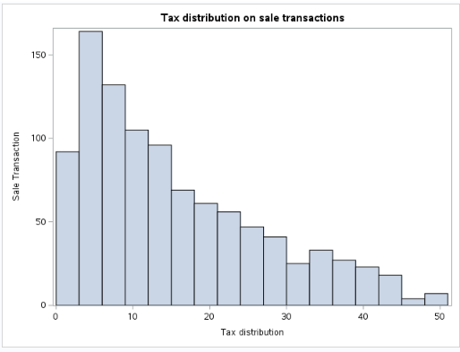

The tax distribution histogram mirrors the income distribution, showing a right skew. This suggests that most transactions have low tax amounts, with higher tax transactions being rare. The majority of transactions fall within the 0 to 10 tax range.

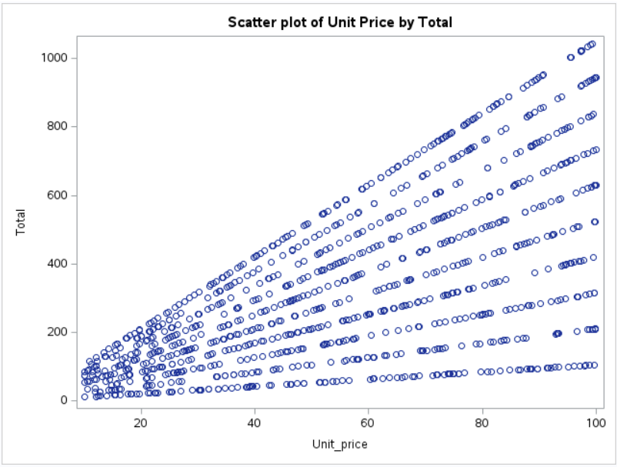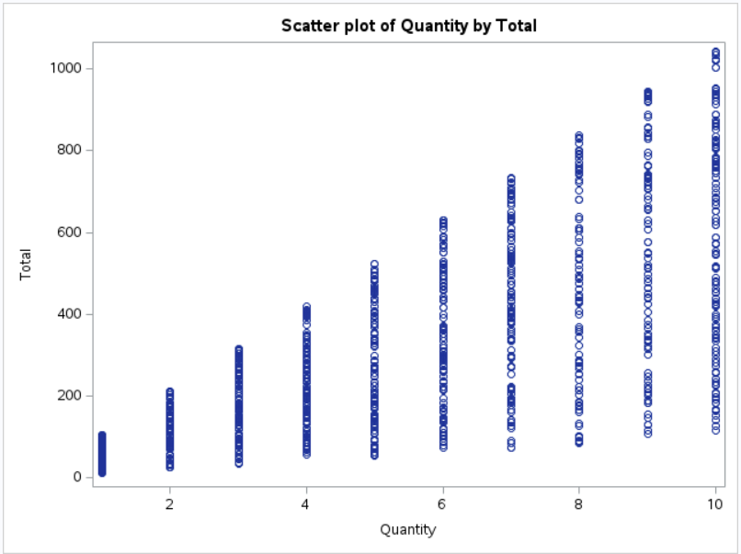
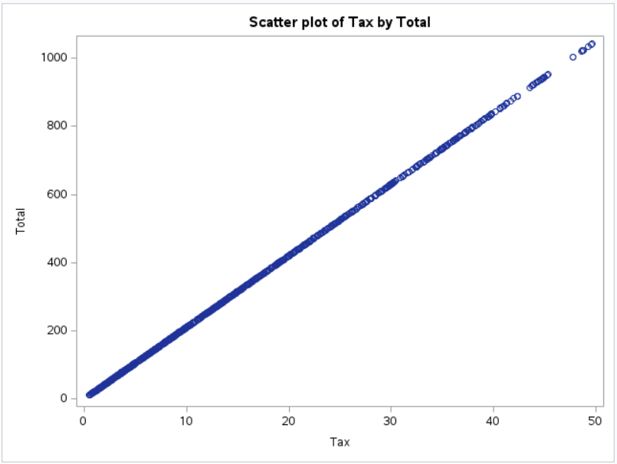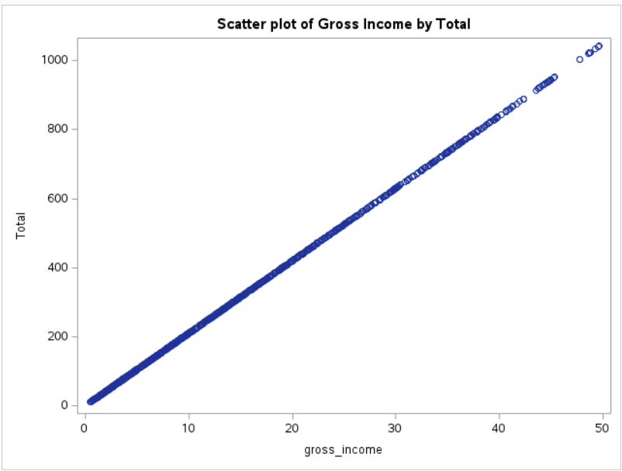

The scatter plots reveal a clear linear relationship between Total and other variables, such as Unit Price, Tax, Gross Income, and Quantity. As these variables increase, Total also rises. This suggests that higher values for Unit Price, Tax, Quantity, and Gross Income are positively correlated with an increased Total.
Given the strong correlation observed between Total and the other variables in the plots, we chose Total as the primary variable for our models. Since the calculation of Total inherently includes contributions from Unit Price, Quantity, Tax, and Gross Income, incorporating Total alone is sufficient for our analysis.

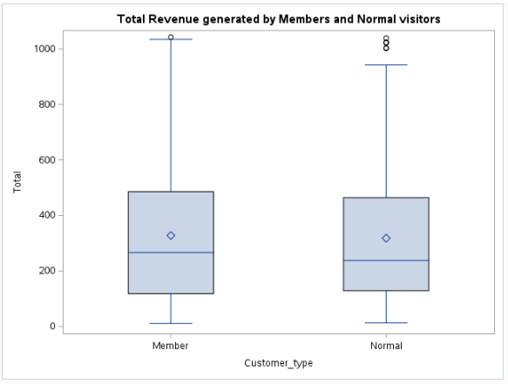

Both member and normal customers show similar mean and median revenues, with members generating slightly higher revenue. Both categories have right-skewed distributions, with members displaying a slightly higher revenue trend. The left whiskers are nearly identical, and the interquartile ranges (IQRs) indicate similar revenue distributions. Notably, normal visitors have a higher deviation due to more outliers compared to members.

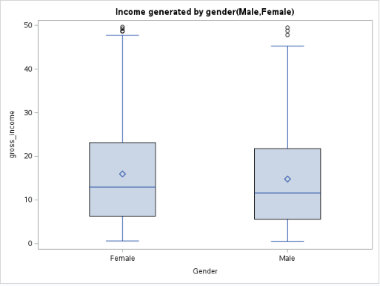

The plot shows that female customers generate slightly more revenue than male customers. Both categories have right-skewed distributions, with the whiskers extending upward. Additionally, the IQR, median, mean, and outliers are similar for both male and female customers.

Principal Component Analysis

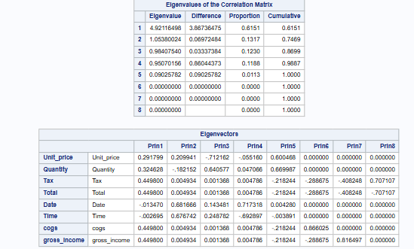

The PCA analysis suggests that correlation is a better approach, as the variables are measured in different units. Regarding the eigenvalues, the first principal component explains 61% of the data variability, while the second accounts for 13%. Together, the first three principal components explain 86% of the total variability.

The most important features in each principal component are as follows:
- Prin1: Tax, Total, COGS, and Gross Income
- Prin2: Date and Time
- Prin3: Quantity
- Prin4: Date and Time
- Prin5: Quantity
- Prin6: COGS
- Prin7: Gross Income
- Prin8: Total and Tax

Model Selection

We have evaluated and compared the performance of several predictive models, including Logistic Regression, CART, Neural Networks, and Discriminant Analysis.

The dataset is split into an 80% training set and a 20% validation set, comprising 800 records for model building. The dependent variable is the rating, with a focus on predicting Rating 1 as the event of interest.

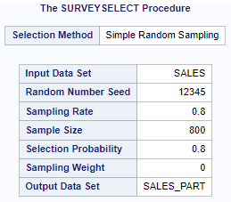

Model 1: Logistic Regression
Dummy variables are created for categorical variables such as Customer_Type, Gender, Product_Line, and Payment to fit the logistic regression model appropriately.
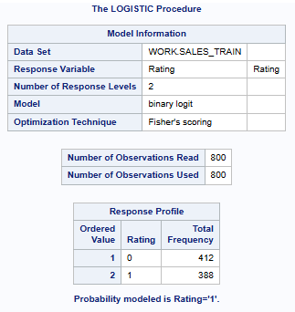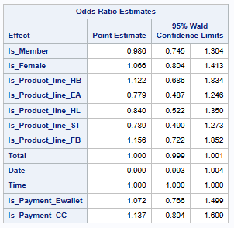
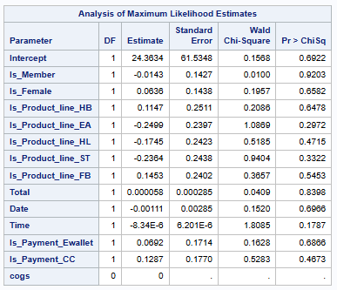
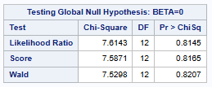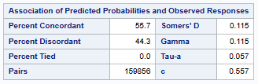
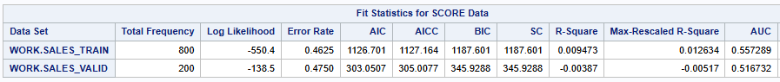
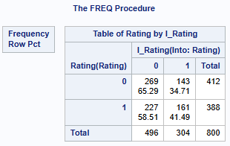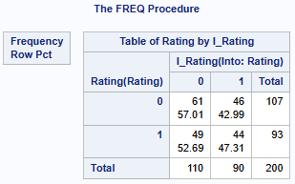

Stepwise Selection Methods

Forward: Only the intercept is included, as none of the variables tested for inclusion meet the statistical significance criterion at the 0.05 level.
Backward: Similar results, with the elimination of the Total, Gross Income, and COGS variables.
Stepwise: Only the intercept is included, as no variables tested for inclusion meet the statistical significance criterion at the 0.05 level.

Logistic Regression Final Model

The final model was built using the variables suggested by the backward selection method, ensuring that all dummy variables of a variable are retained. All measures in the final model are identical to those in the initial model.

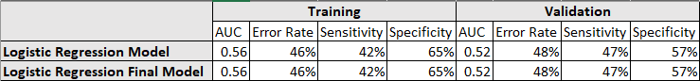

Evaluation of Logistic regression model
- Likelihood Ratio is 0.81 (p-value > 0.05), indicating the model is not statistically significant.
- Variable Significance, Is_Member, Total, Date, Time p-values less than 0.05, suggesting they are statistically significant predictors in this model.
- AUC (Area Under the Curve) is 0.56, which is below the desired threshold of 1. This indicates below-average performance, though within an acceptable range for initial analysis.

Performance Metrics
- Error Rate: High error rates for both model fit and accuracy indicate poor classification performance.
- Sensitivity and Specificity:
  - Training Set: Sensitivity: 42%, Specificity: 65%
  - Validation Set: Sensitivity improved to 4%, while specificity decreased to 57%.
Conclusion
The model demonstrates a high error rate in both its fit and accuracy, indicating poor classification performance. The Area Under the Curve (AUC) remains consistent at 0.56 across both models, reflecting below-average predictive capability.
Notably, the AIC and BIC values are significantly lower in the model accuracy assessment compared to the initial fit, suggesting slight improvements. Sensitivity and specificity metrics further highlight the model's limitations: on the training set, sensitivity is 42% and specificity is 65%, while validation results show a modest increase in sensitivity to 47% and a decrease in specificity to 57%.
There is no evidence of overfitting, but overall, the model’s performance falls below expectations.
Model 2: CART
CART (Classification and Regression Trees) model, which is well-suited for our objective of handling a classification event. Given this classification focus, the model was developed using two key measures, the Gini Index and Entropy.

GINI ENTROPY
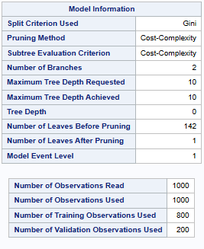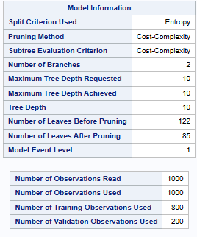
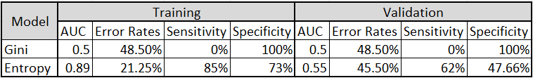

The Entropy model produced a larger and more complex tree, resulting in 85 leaves after pruning. This complexity allowed it to capture more intricate patterns within the data. In contrast, the Gini model generated an overly simplistic tree with only one leaf, failing to capture any meaningful patterns.

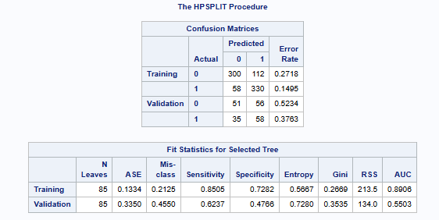
Performance Metrics
- Error Rate: High error rates for model fit is 0.2125, whereas for the model accuracy is increased to 0.4550 indicating poor classification performance.
- Sensitivity and Specificity:
  - Training Set: Sensitivity: 85.05%, Specificity: 72.82%
  - Validation Set: Sensitivity: 62.37%, Specificity: 47.66%
Model Fit Indicators
- AUC on the training data is 0.8906 and, on the test, data is 0.5503. The significant drop in AUC from training to test data suggests overfitting.
Conclusion
The sensitivity and specificity are high on the training set, but drop significantly on the validation set, suggesting poor model performance on test data. The AUC is 0.8906 on the training data but drops to 0.5503 on the test data, showing overfitting.
Model 3: Neural Networks
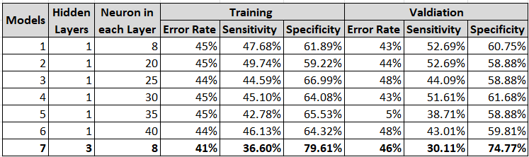
Performance after Adding 3 hidden layer with 8 neurons in each
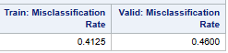
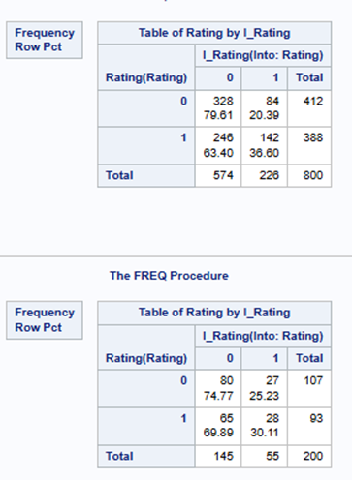
Performance Metrics
Error Rate: The misclassification rate has reduced for training (0.41) and slight change in validation sets (0.46) as compared to previous model.
Sensitivity and Specificity:
Training Set: Sensitivity: 36.60%, Specificity: 79.61%
Validation Set: Sensitivity: 30.11%, Specificity: 74.77%
In Model 7, compared to Model 1, the sensitivity decreased in both the training and validation sets. However, the specificity improved in both sets. Therefore, adding 3 hidden layers with the same number of neurons enhanced specificity but reduced sensitivity, resulting in a moderate performance in terms of the overall error rate.
Thus, we are choosing Model 7 as final model in neural networks.
Model 4: Discriminant Analysis
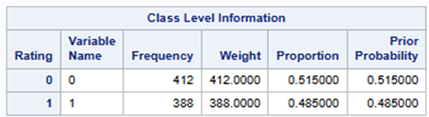
412 observations belong to class 0, ratings unsatisfactory. 388 observations belong to class 1, where ratings are satisfactory. Corresponds to 52% and 48%.
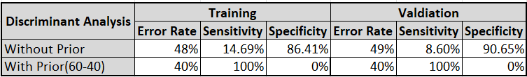

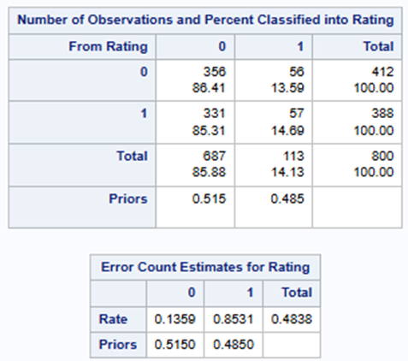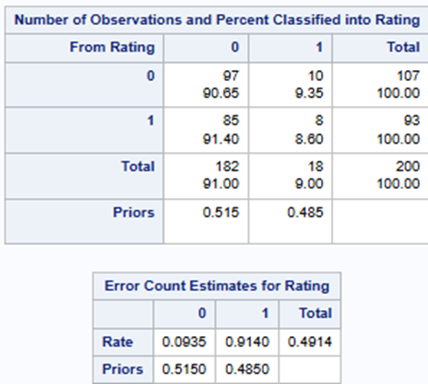
Conclusion
The model performed poorly in terms of sensitivity but showed strong results for specificity. After applying the prior proportion, the model's performance declined, as it struggled to accurately identify specificity.
Model Comparison and Evaluation
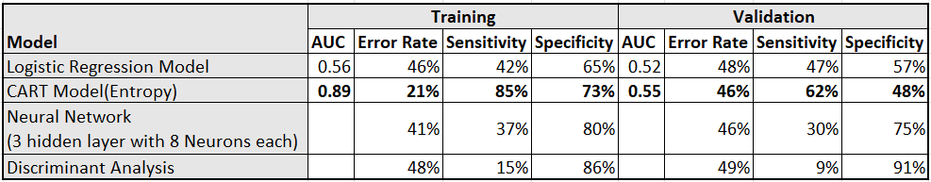
The CART model performs well on the training data, achieving 85% sensitivity, 73% specificity, and the lowest error rate of 21%. It also performed reasonably on the validation data, with 62% sensitivity, 48% specificity, and a 46% error rate.
While the model demonstrates a strong ability to fit the training data, making it a suitable choice for predicting customer satisfaction, the weaker performance on the validation set and the higher error rate suggest signs of overfitting.
Conclusion
Practical Significance and Implications
- Targeted Marketing: Insights on spending behaviors and satisfaction levels of any customer that can be used to create targeted promotions for specific customers including those who are members and those who are not.
- Operational Efficiency: Analysis of date and time trends might be useful for the proper staffing of employees and the proper supply chain management during peak hours.

Inferences
- Key factors influencing customer satisfaction through data-driven analysis - Date and Time.
- Models can predict satisfaction trends across similar customer demographics.

Shortcomings
- Potential biases in the data collection process could impact the generalizability of results.
- The dataset size is relatively small, which might limit the robustness of the findings.

Suggestions for Improvement
- Increasing the dataset size and incorporating the latest data, as we currently have data from 2019, will contribute to greater diversity and help capture a broader range of customer behaviors.
- Incorporate additional variables, such as customer reviews, to improve the accuracy and relevance of predictions.
References
https://www.kaggle.com/code/aryantiwari123/supermarket-sales-prediction/inpu

SAS Code
